
________________________________________________________________________________
Professor: Dr. Dumont
Email: g.dumont@unf.edu
Office: 51/2112
Phone: (904) 620-5855 (office)
(904) 425-9966 (cell)
Class meets: Online on Blackboard (Bb) Starting January 7, 2015
In class: Jan. 7, Feb. 4 and 18, and April 1 and 22, from 6:00 pm – 8:40 pm
Building 3, Room 1371
Office hours: In office: Thursdays 2:00 pm – 6:00 pm and by appointment
On Skype: @GetteinJax (message me informing me who you are so I accept your request)
On Twitter: @GetteinJax
___________________________________________________________________________________

“Education is not the learning of facts, but the training of the mind to think.” – Albert Einstein

Course Summary

While nonprofit organizations are non-profit distributing, the ability to yield a profit is important for survival and sustainability. Still, many nonprofit leaders either do not understand accounting basics or prefer to leave the finances to others who are use to working with numbers. This course will introduce students to the basics of financial management for nonprofit organizations in the United States. These basics start with an introduction to financial accountability and sustainability and then move into the different revenue streams available to nonprofits. It also reviews basic accounting principles and financial evaluations. While this course covers much information with regard to the financial resource management for nonprofits, it is not an advanced finance course. That said, the goal of the course is to provide students with the needed information to be able to manage and monitor a nonprofit’s finances, not prepare students to become a nonprofit accountant. As a whole, the course is far more conceptual than computational. Still, students should complete the course with an understanding of how to analyze a nonprofit’s finances with a critical eye and lose any fear of numbers that they may have.

Contents (quick links)

Course Objectives
Course Materials
Technology Assistance
Instruction/Learning Methods
Course Format
Weekly Overview
Calculation of Grades
Class Policies
Class Schedule
Details on Papers
Memo Rubric
Discussion Board Rubric

Course Objectives

Upon completion of this course, students will have a precursory understanding of the complexities involved in strategic financial management and leading nonprofit organizations in today’s hyper-dynamic environment. Students will also develop and hone skills throughout the course that will enable them to:
- Possess the verbal and writing skills needed to communicate clearly and effectively, make persuasive, professional presentations and convey information essential to the discipline in an orderly and understandable manner.
- Understand the sources and uses of power and its relationship to political events, outcomes and processes.
- Understand the principles of the rule of law and its effects on political relationships, actors, institutions and policy.
- Be able to effectively apply critical thinking and problem solving skills to political issues.

Students will also develop and hone skills throughout the course that will enable them to:
- Verbally communicate clearly and effectively, make persuasive, professional presentations and convey information essential to the discipline in an orderly and understandable manner.
- Write clearly and effectively, make persuasive, professional presentations and convey information essential to the discipline in an orderly and understandable manner.
- Assess the financial health of nonprofits in relation to comparable organizations.
- Assess nonprofit programs and events in relation to the organization’s finances and long-term sustainability.
- Understand how to maximize revenue streams, as well as understand the strengths and weaknesses of each.

[Back to top]

Course Materials

Required Course texts:
- Bell, J., Masaoka, J., and Zimmerman, S. (2010). Nonprofit Sustainability: Making Strategic Decisions for Financial Viability. San Francisco: Wiley.
- Weinstein, S. (2009) The Complete Guide to Fundraising Management. Hoboken: Wiley.
- Dropkin, M., Halpin, J., and LaTouche, B. (2007). The Budget-Building Book for Nonprofits. San Francisco: Jossey-Bass.
- Collins, J. (2005) Good to Great in the Social Sector.
- Relevant current news articles that will be discussed will be posted in the Facebook group UNF NP Concentration/Certificate: https://www.facebook.com/groups/197251970311828/. Please request to join this group to be able to participate.
- All other readings and videos are available online through the UNF library or Blackboard.
- Also please follow my Twitter feed (@GetteInJax). There are links to relevant nonprofit stories as well as the daily publication of Jax Nonprofits online newspaper.
Recommended Materials:
- Follow The Chronicle of Philanthropy, Nonprofit Quarterly, and The Nonprofit Times

In addition to the texts, students are required to become familiar with Blackboard during the first week of class. This site will be utilized for hosting lectures, videos, discussions, important course announcements, student grades, other course materials as well as a tool for you to communicate with your classmates and me. Your memos will also be submitted through Blackboard. If you have any problems doing this, please contact the ITS help desk.

As your student email account is the one I can contact you through Blackboard, you need to make sure that you can access that account. I am well aware that many of you choose to use a different account, but you will need to at the very least, have your student email forwarded to the email address you normally use. If you do not know how to do this, please look into it.

Required Software:
  - Access to Microsoft Word (.doc or .docx). No other files will be accepted.
  - Regular, reliable Internet access using a current, standards-compliant Web browser such as Firefox 3.0+ or Internet Explorer 7.0+, Javascript, and Flash. Click here to see the list of supported browsers and operating systems.

[Back to top]

Technology Assistance
ITS Help Desk - The ITS Help Desk is managed by Information Technology Services. The ITS Help Desk takes phone calls, e-mails, and walk-ins from students, staff, and faculty. The HELP Desk may be contacted for all technical Blackboard questions: login trouble, browser issues, error messages received, etc.
- Phone: 904-620-HELP (4357)
- E-mail: helpdesk@unf.edu
- On Campus: 2nd Floor of the Mathews Building down the hall from the Computer Lab (15/2106).
[Back to top]

Instruction / Learning Methods
This is a highly interactive course that incorporates various teaching media including the textbook, PowerPoint notes, lectures, videos, articles, online learning modules, and peer discussions. As with all university courses, expect to dedicate about 9-12 hours of study per week into this course. The student-centered nature of online learning requires students to be actively involved with and take more responsibility for their own learning. This hybrid course is asynchronous (students may log into blackboard at any time to complete course work). However, students must participate in course discussions and submit work by the deadlines outlined in the course schedule.
[Back to top]

Course Format
The lecture for each week will be available on Blackboard by Friday afternoon. It is highly advisable to complete the readings prior to watching the lectures in order to integrate the material. Once the readings and lectures are completed, students will participate in class discussions on Blackboard. Class meetings will be reserved for discussing the memos from the module noted in the syllabus.
[Back to top]

Weekly Overview
 | Monday | Tuesday | Wednesday | Thursday | Friday | Saturday | Sunday
Assignment | Discussion posts due |  | Responses due |  |  |  | Memos due
Time Due | 11:59 pm |  | 11:59 pm |  |  |  | 11:59 pm

Lectures:
Lectures will be posted on Blackboard under ‘Class Lectures’ tab by Friday at noon, if not sooner. Students should have the readings completed prior to the lecture. I will not review the readings, topic by topic, but I will expect you to know them. Just because I do not discuss something in the lecture, it does not mean that it is not important (there is not enough time to discuss everything that is important, nor do you want to listen to me re-hash all the readings). Students are also responsible for watching any videos that are posted on Blackboard. When applicable, reports that the video is based on will be linked as well, but reading those reports is optional.
Discussion Board: 25% (5 points maximum for each post, 250 maximum points for semester)
The discussion board for each week will be sent up in the following format: and area for general questions about the lecture where you are provided an opportunity to ask me and your classmates questions for clarification about the readings and/or the lecture. Then, there are some threads where I pose some text questions about the readings for you to answer. The purpose of these discussions will be for you to demonstrate to me that you are able to apply the concepts. You are strongly encouraged to pose questions that relate to the readings and the topic(s) being discussed in the different threads for other students as well. These posts will count towards replies (see next paragraph). You will be expected to participate in the discussion board for the 10 weeks of online course work.
Each week, you should answer at least 2 questions in the readings board (with posts in at least two different threads) and reply to 3 (3) posts by others. If done correctly, this will equal 25 points per week (5 posts at 5 points each). You have many opportunities to collect the 250 points. However, you will only be awarded 250 points, so any posts beyond that will not receive additional points.
Please note, I WILL NOT TOLLERATE BIASED information!!!! DO NOT get your information from a blog or social networking site. News items must be obtained from a MAINSTREAM news source. No Keith Olbermann, Bill O’Reilly, Rachel Maddow, Glenn Beck, etc. (or whomever the local blogger is that you may follow). They are commentators and provide opinions, not news. Also, research has demonstrated that Fox news and MSNBC report the news with a right and left leaning (respectively) slant. Do not use these outlets for information.
For more information on the grading of discussion board posts, see Discussion Board Rubric.
Class Participation – 20% (200 points)
This class will meet five times during the semester: January 7, February 4 & 18, and April 1 and 22. These meetings are reserved for discussing the memos note in the syllabus. Lectures and discussion board postings are still applicable for these weeks.
Students will be evaluated in each in-class meeting on the quality of their participation in class discussions. These five classes align with the conclusion of a core module: the Nonprofit Sector, Nonprofit Financial Sustainability, Nonprofit Revenue Streams, and Future Challenges in Nonprofit Financial Management. These classes will provide an opportunity to discuss each student’s completed memo.
There are no formal presentations for the module wrap-up classes. Still, students should arrive ready to discuss and defend their memos. The class on April 22 will be the final exam and a presentation. There is more detail below on the final.
For more information on the grading of class participation, see Class Participation Rubric.

Online Introduction – 5% (50 points; 30 points for your initial post; 10 points for each reply to at least two other students’ post.)
This initial writing assignment will allow the professor to 1) provide critical feedback on the students’ writing style, and 2) give students a chance to learn more about their classmates.

Three Memos – 30% (300 points, 100 each memo)
Students will write and submit two Memorandums (Memos). The topics for the memos align with the course topics. The assignment specifics are noted in the date they are due.

These memos will be due prior to noon on the Sunday the week the assignment is due, which is noted in the Class Schedule section of the syllabus. As noted above, it will not be accepted if uploaded late.

Memos are due by 11:59 pm on the Sundays designated in the course schedule. There are absolutely no exceptions to the submission requirements.
See Memo Rubric below for more information on how this portion of your grade is calculated.
Final and Presentation – 20% (200 points; memo is worth 100 points; presentation is worth 100 points)
The final is comprised of one final memo and the presentation of that memo. The memo will be 1 to 2 pages (not including the works cited section) and will discuss the two most important topics for the future of your organization or agency and support your decision with readings from the semester and outside readings where appropriate. The grading rubric for the final memo is the same as the class memos.

Students should be ready to present their memo to the class. This does NOT mean reading them word for word out loud. Students should summarize the memo, as if they were presenting it to the Board of Directors of the nonprofit organization. The use of technology is available (i.e. PowerPoint, YouTube, Facebook, etc.).

Each presentation should last no longer than five minutes. Questions from fellow students are strongly encouraged! Remember, this is to be done in a professional manner.

See Presentation rubric below.

[Back to top]

Calculation of Grades
The following is a breakdown of how the grades will be determined:
Introductory post | 5% (50 points) | The grading scale is as follows:
Class participation | 20% (200 points)
Discussion board posts | 25% (250 points) | A 940 – 1000; A- 900-939
Memos (100 pts each) | 30% (300 points) |  | B+ 870 – 899; B 840 – 869; B- 800 - 839
Final memo | 10% (100 points) |  | C+ 770 – 799; C 700 – 769
Presentation | 10% (100 points) |  | D 600 – 699
 | (1000 points) |  | F < 599
To calculate your grade, simply add the total points earned to determine how many more points you need to get your desired grade.

[Back to top]

Class Policies

Attendance:
There is a strong positive correlation between class attendance and student performance. In addition, this is a professional program and as such, it should be approached in a professional manner. I expect you to show up for every class (all 5), as you would employer meetings. Being in class affords you the opportunity to ask questions and learn from your fellow students. When you are not able to attend, please email me.

Tardiness:
I expect all students to get to class on time and remain in class for the duration of the class period. If you are late, you will be marked absent. If tardiness becomes a problem, I will lock the door at the beginning of class and will not let late students in. If you come to class late due to work, it is expected that you will enter the room in a quite, non-disturbing manner and participate fully while in attendance. Please look into all available avenues with your employer to be able to be in class on time.

Breaks:
Please ensure that all your personal business is completed before class. DO NOT get up and leave the room; I find it to not only be distracting, but rude. If you have an emergency, that is fine, but an emergency must be an emergency, and emergencies do not happen often.

Given that this class is longer than three-hours, there will be breaks throughout the class to rejuvenate. Please return to class by the end of break so that the class can proceed with minimal interruptions. There is a lot of information that needs to be covered, so your promptness with regard to time is much appreciated.

Early Dismissal:
Do not leave class early unless you have informed me prior to the beginning of class that you need to leave. If you leave early, I will mark you absent for the whole class unless you have received prior approval.

Decorum:
I expect professional decorum at all times. I expect all students to show each other respect and debate in a professional manner. Ad hominems are NOT allowed. This is a class about public issues and, at times, emotional issues will be discussed. I will not tolerate students attacking each other, verbally or otherwise, over their views. Perspectives, and others’ responses to them, need to be based on data, not ideology or beliefs. If you do not know the data, research it before class and be ready to provide the source of the data (e.g. census bureau, text book, etc.).
Late assignments/make-up exams:
I do not accept late work. I will not extend a due date for a student regardless of personal, health, or technical issues. I have an ethical obligation to follow the printed policies to maintain a fair/consistent learning environment for every student. I encourage you to submit your work two days before the deadline. I strongly encourage you to work ahead.

If you have a rare situation that requires an exception, you must notify me well in advance for consideration. If you are granted the rare the rare extension, late papers will be penalized by having one letter grade deducted for every day it is late. There are no extensions given for discussion board posts. Any posts done after the deadline will not be graded.
Academic Dishonesty:
Cheating, through any means, will not be tolerated in this course. You are not only cheating yourself (any wasting your money), it is unfair to students who do not seek an ‘easy’ way to obtain their desired grade. The followings statements are from UNF’s Catalog (http://www.unf.edu/catalog/catalog.aspx?id=15032403681).
Course Content
A course may deal with subjects, issues, or perspectives to which some might object. Such objections will not exempt a student from course requirements. The University of North Florida stands behind the right of its instructors to include material that is challenging in any number of ways. The faculty urges students to discuss any concerns they might have concerning the content of their courses with their instructors.
Claiming One’s Own Work
Each student is honor-bound to submit under his or her name or signature only his or her own work; to fully acknowledge his or her use of any information, ideas, or other matter belonging to someone else, and to properly document the source in question; and to offer for credit only that work which he or she has completed in relation to the current course.
Violations of Academic Integrity
Under this heading the University of North Florida Student Handbook identifies several types of violations; these include but are not limited to: cheating; fabricating and falsifying information or citations; submitting the same work for credit in more than one course; plagiarizing; providing another student with access to one’s own work to submit under this person’s name or signature; destroying, stealing, or making inaccessible library or other academic resource material; and helping or attempting to help another person commit an act of academic dishonesty. The University of North Florida authorizes any instructor who finds evidence of cheating, plagiarism, or other wrongful behavior that violates the University of North Florida Academic Integrity Code to take appropriate action. Possible action includes, but is not limited to, failing the student on the work in question, failing the student for the course, notifying the appropriate academic dean or Vice President for Student Affairs, and requesting additional action be taken.
The consequences of a breach of academic integrity may result in an F, which is unforgivable, regardless of withdrawal status. To view the Student Handbook, click here.
To ensure equity in the grading process, I make every effort to catch students who are being dishonest. To date, I have had to fail at least one student per semester due to plagiarizing another’s work. I would love to change this statement next semester, so please do not plagiarize or cheat. Odds are I will catch you.
Disabilities:
Students with disabilities who seek reasonable accommodations in the classroom or other aspects of performing their coursework must first register with the UNF Disability Resource Center (DRC) located in the College of Education and Human Resources (Building 57), Room 1500. DRC staff members work with students to obtain required documentation of disability and to identify appropriate accommodations as required by applicable disability laws including the Americans with Disabilities Act (ADA). After receiving all necessary documentation, the DRC staff determines whether a student qualifies for services with the DRC and if so, the accommodations the student requires will be provided. DRC staff then prepares a letter for the student to provide faculty advising them of approved accommodations. Military and veteran students who return from combat exposure may be utilizing the post 9/11 GI bill to continue postsecondary education goals. For further information, contact the DRC by phone (904) 620-2769, email (drc@unf.edu), or visit the DRC website (http://www.unf.edu/dept/disabled-services).
Military and veteran students may need both physical and academic accommodations. Contact Ray Wikstrom, Director of Military and Veterans’ Resource Center by phone (904) 620-2655, or by email at ray.wikstrom@unf.edu. You can also visit their website at: http://www.unf.edu/military-veterans/.

Department of Political Science and Public Administration website:
Students are strongly encouraged to visit the Political Science department’s website for information. This site is up-to-date with information that will assist students in contacting faculty and staff, exploring graduate studies, researching career options, and accessing important details related to undergraduate programs and activities. For important information on the Department of Political Science and Public Administration, please visit: http://www.unf.edu/coas/pspa/
UNF’s MPA Nonprofit concentration and Nonprofit Graduate Certificate program has a Facebook group to share information (https://www.facebook.com/groups/197251970311828/). If you use Facebook, please join the UNF NP Certificate group to receive updated information and opportunities.
Student Obligations:
I expect you to be prepared. This means to make sure you have completed the readings before the discussion. You should be ready to answer questions about the readings and current affairs. If you have any questions or concerns, please let me know. I will make myself available to help you outside of my office hours if necessary.

Professor Obligations:
- I will review and respond to email messages daily. You should have an email response within 24-48 hours. My contact is listed at the beginning of the syllabus. Please note that I am not on the computer every minute of the day. When emailing me, you can expect a response within 24-48 hours, Monday through Friday. I make every attempt I can to NOT be online on weekends. That said, it is best to contact me during the week with any questions. Plan your time accordingly. If you do not hear from me within 48 hours, email me, call me, FB message me or Tweet me to let me know you are trying to get in touch with me. There are times when student emails go into my junk folder.
  - For consistency, I will review and grade all students’ memos and discussions after the due date. I will grade all student work on the same day. I will not check or grade work before the deadline.
  - I will provide you with detailed feedback on your memos. Check through “my grades.”
  - I will notify students of any changes or updates in the course through ANNOUNCEMENTS.
  - I will use the ANNOUNCEMENT function on Bb to regularly communicate and provide additional resources and information as they become available.
  - I will provide evaluation criteria and specific directions for all course assignments (in this syllabus).
  - I will provide the PowerPoint slides to compliment and add the chapters and augment learning. (Note: The PowerPoint slides are NOT enough to complete the memos and discussions.)
  - I will be available for online office hours daily via Skype. I am also available on the phone and in person. I welcome the opportunity to help you!

[Back to top]

**All dates denote the Wednesday of the scheduled week.**
Class Schedule: *
(subject to change)
Week | Date  (red denotes in class) | Topic | Monday  11:59 pm | Wednesday  11:59 pm |  |  | Memo due
1 | 1/7 | Introductions
The Nonprofit Sector – Module 1
2 | 1/14 | Sector Basics | Initial post | Replies
3 | 1/21 | The Scope of the Sector | Initial post | Replies
4 | 1/28 | Financial Accountability | Initial post | Replies
Sustainability – Module 2
5 | 2/4 | The Business Model
6 | 2/11 | Strategic Financial Planning | Initial post | Replies |  |  | 1
Revenue Streams – Module 3
7 | 2/18 | Fundraising Planning
8 | 2/25 | Fundraising Groundwork | Initial post | Replies |  | 2
9 | 3/4 | Revenue Streams 1 | Initial post | Replies
10 | 3/11 | Revenue Streams 2 | Initial post | Replies
 | 3/18 | SPRING BREAK!!!!
11 | 3/25 | Revenue Streams 3 | Initial post | Replies |  |  | 3
Budgets! – Module 4
12 | 4/1 | Budgets: The Basics
13 | 4/7 | Budget Guidelines | Initial post | Replies
14 | 4/14 | Budgets: Evaluations | Initial post | Replies
Future Challenges – Module 5
15 | 4/22 | Future Challenges

Week 1: January 7 Introductions (in class)

Module 1: Introductions and the Nonprofit Sector

Week 2: January 14 Sector Basics
Readings:
  - Boris (1998) Myths About the Nonprofit Sector (available on Blackboard)
  - Dees and Anderson (2003) Sector Bending (available on Blackboard)
  - Collins (2005) Good To Great in the Social Sector

Week 3: January 21 The Scope of the Sector
Readings:
  - Boris & Steuerle (2006) Scope and Dimension of the Nonprofit Sector (available on Blackboard)
  - The Nonprofit Sector in Brief 2010 (available on Blackboard)
  - The State of the Nonprofit Sector: The First Coast 2012 (available on Blackboard)
  - The Jacksonville 80 (available on Blackboard)
  - Optional: Young (2007) Why Study Nonprofit Finance? (available on Blackboard)
Video:
  - Know Your Sector (3:40)

Week 4: January 28 Financial Accountability
Readings:
- Bell (2010) Financial Leadership in Nonprofit Organizations (available on Blackboard)
- Young (2010) Nonprofit Finance: Developing Nonprofit Resources (available on Blackboard)

Module 2: Sustainability
Week 5: February 4 The Business Model (in class)
Readings:
- Bell, et al. (2010) – Parts 1-3 (Chapters 1-9)
Video:
- The Business Model (3:00)

Week 6: February 11 Strategic Financial Planning
Readings:
- Bell, et al. (2010) – Parts 4 & 5 (Chapters 10-13)
MEMO 1 DUE [2/15 by 11:59 pm] – Your board has asked you about this thing called nonprofit sustainability. They want you to inform them about what it is, why it is important, and how it would be applied to this organization. Use at least two model described in Bell, et al. (one from part 3 and one from part 4) as an example of the process to measure sustainability. Link the importance of programs, funding, and expenses to the organization’s mission.

Module 3
Week 7: February 18 Fundraising Planning (in class)
Readings:
- Weinstein – Chapters 1-3

Week 8: February 25 Fundraising Groundwork
Readings:
- Weinstein – Chapters 4-6
- AFP Code of Ethical Principles and Standards
- Infograph: 2012 Millennial Report
Video:
- 5 Key Findings (2:40)

MEMO 2 DUE [3/1 by 11:59 pm] – Your board has asked you to highlight what the organization needs to do to be better prepared to meet next year’s funding goals. Please provide them with a plan, along with justifications, for the organization to accomplish is campaign goals next year.

Week 9: March 4 Revenue Streams I
Readings:
- Weinstein – Chapters 9-11
Video:
- Local Focus: Lasting Impact (1:10)

Week 10: March 11 Revenue Streams II
Readings:
- Helm (2010) Social Enterprise and Nonprofit Ventures (available on Blackboard)
- Rushton and Brooks (2007) Government Funding of Nonprofit Organizations (available on Blackboard)
- James and Young (2007) Fee Income and Commercial Ventures (available on Blackboard)
- Weinstein – Chapter 12
Video:
- Social Enterprise (4:16)

March 18 – Spring break. No Class

Week 11: March 25 Revenue Streams III
Readings:
- Weinstein – Chapters 7, 8, 13, and 14
MEMO 3 DUE [3/29 by 11:59pm] – The board is disappointed with the organization’s current revenue generating levels. It wants you to recommend ways to implement a successful fundraising campaign and a possible new revenue stream. They also want to know how to measure whether or not it was successful, other than the amount of money raised. Be specific, provide examples, and justify your recommendations.

Module 4: Budgets!
Week 12: April 1 Budgets: The Basics (in class)
Readings:
- Dropkin, et al – Chapters 1-6

Week 13: April 8 Budget Guidelines
Readings:
- Dropkin, et al – Chapters 7-22

Week 14: April 15 Budget wrap-ups and Financial Evaluation
Readings:
- Dropkin, et al – 23 & 24
- Barr (2008) Analyzing Financial Information Using Ratios (available on Blackboard)
- Weinstein – Chapter 16
- News article (on BB) Do Nonprofits really Limit Advertising (rebuttal to Pallotta)
- News article (on BB): 50 Worst Charities in the US
- New Article (on BB): Nonprofits Need to Denounce Bad Fundraising Practices
Video:
- Pallotta (18:55)

Module 5: Future Challenges

Week 15: April 22 Future Challenges (in class)
Readings:
- Burk (2011) Where Philanthropy is Headed in 2011 – Executive Summary (available on Blackboard)
- Gowdy et al. (2009) Convergence: How Five Trends Will Reshape The Social Sector (available on Blackboard)
Video:
- Nonprofit Sector trends to Watch (4:31)
- 5 Predictions for the Nonprofit Sector (4:32)
- The Future of the Nonprofit Sector: A Millennial Takeover (1:16)

FINAL MEMO DUE – The board is aware that a lot is going on in our current environment that can impact the organization. Connecting all of the materials covered throughout the semester, how would the challenges presented in this week’s readings impact your nonprofit? Be specific and provide recommendations on how the organization should deal with them.
[Back to top]

Details on the Memos

Reminder – all memos are to be submitted through Blackboard in the appropriate tab.

Memos
Memos should be formatted as memos. In other words, use the following format:

To:
From:
RE.

First paragraph: let your reader know what the memo is about
Subheading (what this section is discussing)
Discuss
Subheadings (what this section is discussing)
Discuss
Use as many subheads you need to clearly complete the assignment.
Concluding thoughts

More on the memos
Style & Audience: The memo should be organized as a professional, formal memorandum to the board of directors of a nonprofit organization that you will use the whole semester. Memos should be well organized, clear, and succinct. The audience for the memo should be real, and preferable based on your current job. If you are not currently employed in the nonprofit sector, then you must pick an organization that you can gain access to pertinent information (such as organizational structure, programs, etc.).
The same nonprofit organization will be used for both memos.
Format and Length: This is a professional program, thus professional presentation and language use is expected. Grades will reflect content, analysis, presentation, grammar and language use. All written assignments must be fully referenced and include appropriate in-text citations and a full bibliography. Memos should be no more than 2 pages long (not including works cited section), single-spaced text with double spaces between paragraphs. Use subheadings and organizing sentences to guide the reader.
[Back to top]

Memo Rubric

Your papers should follow these guidelines:
- Identify the issue/state the question (5 points)
- Content (40 points)
- Write professionally (30 points)
- Cite sources in text, correctly (15 points)
- Follow instructions/feedback (10 points)
_____________________
- Identify the issue/state the question, main theme, etc.
  - Avoid the 'mystery novel' approach to professional writing. Tell your reader in the first paragraph, if not the first line, what the paper seeks to do. Do this as clearly as possible, with a "This paper will..." statement, if necessary.
- Content
  - Self explanatory. Note that the likelihood of misinterpreting what you've read (or falling for a particularly biased, distorted take on an issue) is inversely related to the amount of reading that you do. If you have any questions about the readings, please contact me, or ask for clarification on the discussion board from your peers.
  - Note that this is a class about nonprofit management, not the management of private companies.
- Write professionally
  - Self explanatory.
  - Write for an informed layperson on the street, rather than for experts, idiots, or your class teacher.
  - Use quotations sparingly. This is meant to be a paper by you, not a collection of selected quotes that you thought were especially relevant to the topic.
  - Use a professional tone. Don't force it. Some pet hates (you WILL points!!!!):
    - Use third person; don't use first person (e.g. I, we, our), or second person (you). You are not writing this from yourself, you are writing it on behalf of an organization, to an impersonal audience.
    - Don't use contractions (e.g. don't).
    - Avoid rhetorical questions (e.g. Why is this the case?).
    - Avoid starting a sentence with a conjunction (e.g. The paper was bad. And she started a sentence with and.).
    - Avoid singular/plural inconsistency (e.g. The student lost points for singular/plural consistency in their paper). Please note, that when referring to an organization, it is a single organization (or unit of government, or agency) and it should be referred to as “it”, not “their” or “them.”
- Cite sources correctly, in text and in the bibliography
  - EVERY paper must include course readings.
  - Please use APA. Key points:
    - Sources must be retrievable. Given the in-text citation, your reader should be able to go directly to the appropriate full citation in your list of works cited (or bibliography), and from this to the page (though this is sometimes tricky with web sites) of the document from which you got the information.
      - This means that if you cite something as (Smith 2000) in the narrative, the source should be listed alphabetically under Smith in the list of works cited.
      - Do not cite urls in text.
      - Note that you must have a proper list of works cited.
        - Everything cited in text must be in this list of works cited; anything not cited in text should not be in this list of works cited.
    - Bibliographic references should be informative on their own. Listing a url is not enough, as your reader should be able to get some idea where the information is from, so that s/he does not have to go to the source to get some idea of credibility.
    - You don't need a quotation in order to include a citation.
    - Example of in-text citation: (Shafritz, et al. 2013). Example of Works Cited citation: Shafritz, J. M., Russell, E. W., & Borick, C. P. (2013). Introducing Public Administration (8th ed.). New York: Pearson Longman.
    - Note, again, the admonishment against plagiarism, and consult UNFs Academic Honesty Policy. If you are caught plagiarizing, you will fail the assignment, and possibly the class!
- Follow instructions
  - Self explanatory. Pay attention to the various course requirements.
  - Formatting the paper is included here.
  - Especially note UNF’s Academic Integrity Policy.
- Not addressing feedback (debits)
  - I take a lot of time to provide you with detailed feedback. If you make the same mistakes in a subsequent paper, you will loose points. The more times you make the mistakes, the more points you lose.
[Back to top]

Rubric (visual)
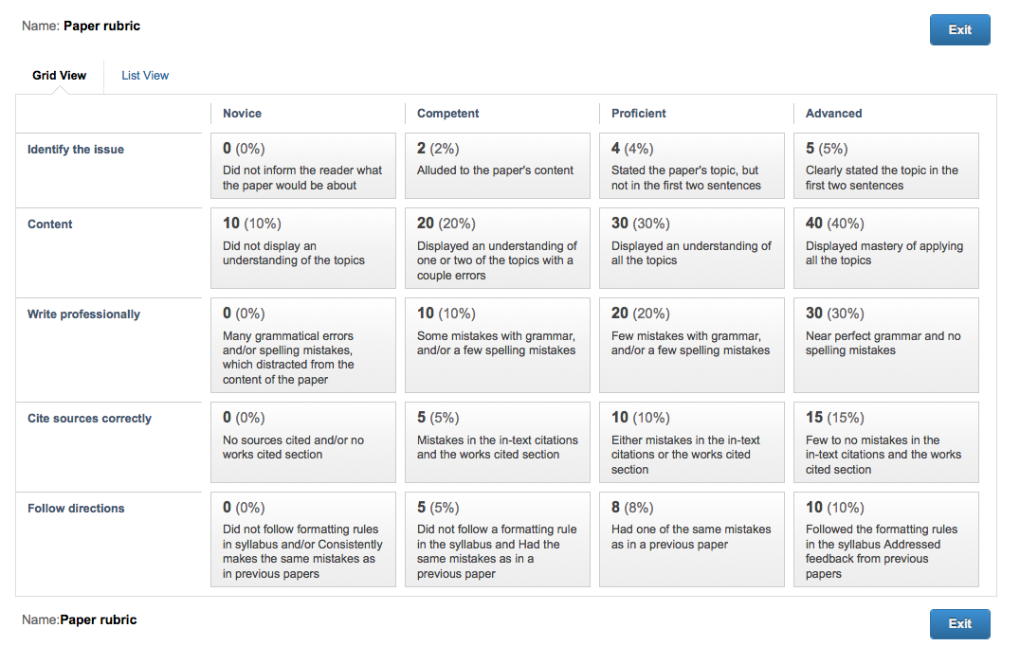
[Back to top]
Common Comments on Past Papers (don’t do these things)
I have found that I have had to repeatedly use the same comments over and over again on student papers. To avoid having to keep repeating this, below is a list of comments addressing common mistakes that are made on student papers. Please read through each, and follow the link for more clarification. The links are pretty fun, so I would follow them to see where they go...

Grammar
- [Restrictive versus unrestrictive clauses. Here is a great link when and how to use which v that: http://grammar.quickanddirtytips.com/which-versus-that.aspx]
- [Improper semi colon use. See http://theoatmeal.com/comics/semicolon for a good (and humorous) summary]
- [Use ‘who’ when referring to people and use ‘that’ when referring to things. Here is a link that goes into more detail: http://grammar.quickanddirtytips.com/who-versus-that.aspx]
- [Wrong form. They’re v there v their. See http://englishplus.com/grammar/00000256.htm]
- [Here is a great link on when to use affect v effect: http://grammar.quickanddirtytips.com/affect-versus-effect.aspx]
- [Here is a good link for when to use ‘a’ and when to use ‘an’: http://grammar.quickanddirtytips.com/a-versus-an.aspx]
- [Pronouns refer to the noun that immediately precedes them. See http://www.grammarbook.com/grammar/pronoun.asp]
- [Spell out single digit numbers. Here is a good link about writing numbers: http://www.grammarbook.com/numbers/numbers.asp]

Professional Writing
- [Don’t use first person. See syllabus]
- [Do not use contractions. See syllabus.]
- [Too informal for a professional paper]
- [Only capitalize formal names and titles]
- [Avoid rhetorical questions. See syllabus.]
- [Spelling – proofread!]

Citing
- [When the information can be found in in the text, cite the text, not me.]
- [Include all the authors of a book. If more than three, use the first author’s last name followed by ‘et al. (year).’]
- [When citing from an edited book, you must use the author of the chapter’s name, not the editor.]
- [See APA on how to cite from edited volumes in text and the works cited section.]
- [You must include the page number whenever using a direct quote.]
- [Citations must go within the sentence. See syllabus.]
- [Authors’ names must go in the order that they are listed on the book or article.]
- [There are no in-text citations. You need to let the reader know where you are getting the information.]
- [Do not use book titles in text. See syllabus.]

Formatting/ Following directions
- Times New Roman, 12 point font
- 1 inch margins

Discussion Board Rubric
Postings: (total of 300 points for the semester)
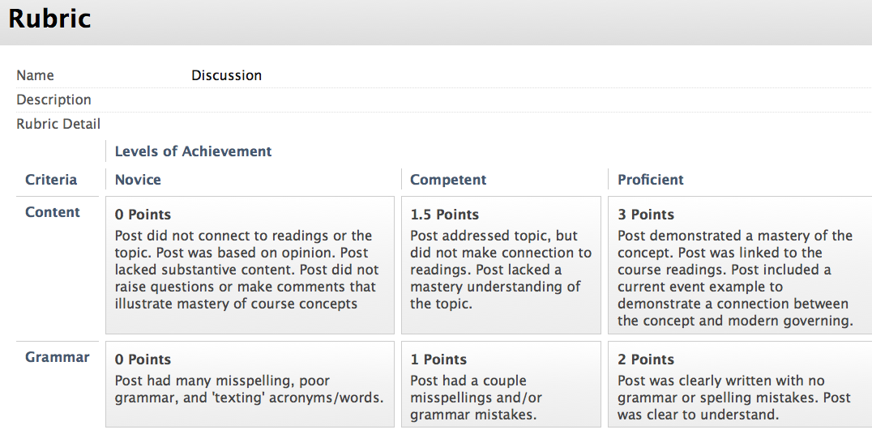[Back to top]

Class Participation Rubric

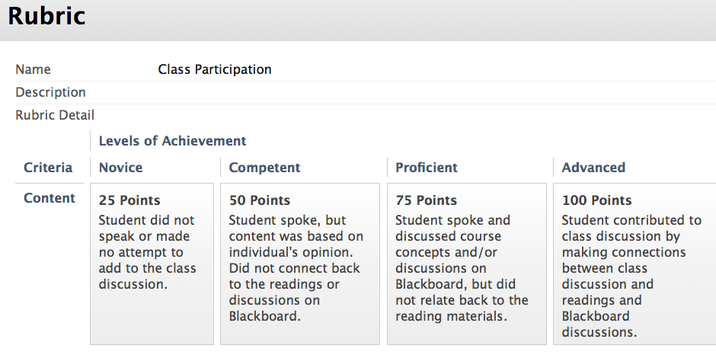

[Back to top]

Morris, J., and P. Francia 2009. Cable News, Public Opinion, and the 2004 Party Conventions. Political Research Quarterly, published online. Available at http://prq.sagepub.com/content/early/2009/07/20/1065912909338463.full.pdf+html, accessed 7/20/2010 and Project for Excellence in Journalism 2008. The Color of News. Pew Research. Available at http://www.journalism.org/node/13436, accessed 7/20/2010.

